# Android Building Blocks

* Activity
* Service
* Broadcast Receiver
* Content Providers

Make data of our application shareable

# Permissions (2-way)

* Manifest

Add a uses-permission line in the manifest file

* Code

After the M version of the Android, put min SDK 23

## Code for permission to launch Camera











# Activity Stack

Each activity gets pushed on to the stack

Back Click button calls finish method that pops out the last activity

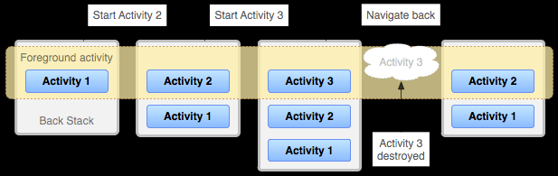

Set Parent of an activity



Go to Parent Activity



## Logout

